
Bharati Vidyapeeth
(Deemed to be University)
Department of Engineering and Technology Computer Science and Engineering
Navi Mumbai (2026–2027)

A PROJECT REPORT
ON

Open-Dataset Benchmark & Standardized XAI Evaluation Metric Suite

Submitted in partial fulfillment of the requirements of the degree of

BACHELOR OF TECHNOLOGY
Computer Science and Engineering
by

- Rishith Mogaveera (Roll No. 01)
- Vagisha Kumari (Roll No. 23)
- Aatif Swalake (Roll No. 36)
- Nidhi Mahadik (Roll No. 38)

Guide
Dr. Srijita Bhattacharjee

Certificate
This is to certify that the project entitled “Open-Dataset Benchmark & Standardized XAI Evaluation Metric Suite” is a bonafide work of

  - Rishith Mogaveera (Roll No. 01)
  - Vagisha Kumari (Roll No. 23)
  - Aatif Swalake (Roll No. 36)
  - Nidhi Mahadik (Roll No. 38)

submitted in partial fulfillment of the requirement for the award of the degree of “Bachelor of Technology” in “Computer Science and Engineering” at Bharati Vidyapeeth (Deemed to be University), Navi Mumbai.

(Dr. Srijita Bhattacharjee) Guide

(Dr. Nidhi Sharma)
Head of Department
(Dr. Mohan Awasthy) Principal

A PROJECT REPORT
on

“Open-Dataset Benchmark & Standardized XAI Evaluation Metric Suite”

Submitted By

- Rishith Mogaveera (Roll No. 01)
- Vagisha Kumari (Roll No. 23)
- Aatif Swalake (Roll No. 36)
- Nidhi Mahadik (Roll No. 38)

is approved for the award of “Bachelor of Technology” degree in “Computer Science and Engineering”.

Examiners

1.

2.

Date:
Place: Navi Mumbai

ABSTRACT

Machine Learning models are increasingly used to analyse data and support decisions, including in healthcare-related applications. However, prediction performance alone does not explain why a model produced a particular output. Explainable Artificial Intelligence (XAI) provides techniques for examining model behaviour and presenting feature-level explanations. The project, “Open-Dataset Benchmark & Standardized XAI Evaluation Metric Suite,” focuses on a structured framework for comparing SHAP and LIME explanations under consistent experimental conditions, using the Cleveland Heart Disease Dataset as the intended open-data case study and Logistic Regression and Random Forest as baseline prediction models. The evaluation framework considers three dimensions: faithfulness, which examines whether an explanation reflects the behaviour of the underlying model; stability, which considers whether explanations remain consistent under controlled input changes; and sparsity, which considers how many features are needed to represent an explanation. A fair comparison requires explicit metric formulas, preprocessing rules, perturbation settings, metric directions, and reproducible configurations. This report describes the motivation, related work, proposed methodology, software requirements, design, testing plan, and intended evaluation outputs. Numerical findings are not stated because they must be obtained from a verified execution of the project. The framework is intended for academic experimentation and does not provide medical diagnoses.

Keywords: Explainable Artificial Intelligence, SHAP, LIME, Machine Learning, Faithfulness, Stability, Sparsity, Cleveland Heart Disease Dataset, Benchmarking.

ACKNOWLEDGEMENT
We thank our project guide, Dr. Srijita Bhattacharjee, for guidance in selecting the demon stration topic, organising the report, and reviewing the proposed design. The discus sions helped us connect the project requirements with a clear system structure.

We also thank the Head of Department, Dr. Nidhi Sharma, and our Principal, Dr. Mohan Awasthy, for their encouragement and support.
We acknowledge the faculty and staff of Department of Engineering and Technology, Bharati Vidyapeeth (Deemed to be University), Navi Mumbai, for their assistance during this learning exercise.

Preparing this demonstration has helped us understand the relationship between requirements, design, implementation, and evaluation

Smart Library Management System

LIST OF FIGURES

FIG.NO | NAME OF FIGURE | PAGE
1 | SHAP-Based Explanation System | 12
2 | LIME-Based Explanation System | 13
3 | System Architecture | 16
4 | RANDOM FOREST EVALUATION | 20
5 | MEAN STABILITY | 21
6 | SVM EVALUATION | 22

LIST OF TABLES

NO. | NAME OF TABLE | PAGE
1 | Literature survey | 10
2 | Evaluation Dimensions | 17
3 | Hardware and Software Requirements | 18
4 | Implementation plan | 18
5 | Testing and Evaluation | 19

TABLE OF CONTENTS
Abstract . . . . . . . . . . . . . . . . . . . . . . . . . . . . . . . . . . . . . 4
Acknowledgement . . . . . . . . . . . . . . . . . . . . . . . . . . . . . . . . 5
List of Figures and Tables . . . . . . . . . . . . . . . . . . . . . . . . . . . . 6
Table of Contents . . . . . . . . . . . . . . . . . . . . . . . . . . . . . . . . 7

Chapter 1 – Introduction
  - Introduction . . . . . . . . . . . . . . . . . . . . . . . . . . . . . . . . . 8
  - Motivation . . . . . . . . . . . . . . . . . . . . . . . . . . . . . . . . . 8
  - Objective . . . . . . . . . . . . . . . . . . . . . . . . . . . . . . . . . 8
  - Scope . . . . . . . . . . . . . . . . . . . . . . . . . . . . . . . . . 8
  - Application . . . . . . . . . . . . . . . . . . . . . . . . . . . . . . . . . 9

Chapter 2 – Literature Survey
  - Literature Survey Table . . . . . . . . . . . . . . . . . . . . . . . . . . . 10
  - Survey of Existing System . . . . . . . . . . . . . . . . . . . . . . . . . 13
  - Research Gaps 15
Chapter 3 – Proposed System
  - Problem Statement and Objectives 16
  - Scope 16
  - System Architecture 16
  - Methodology 17
  - System Design 17
  - Hardware and Software Requirements 18
  - Implementation 18
  - Testing and Evaluation 19
Chapter 4 – Results and Conclusion
  - Results 20
  - Result Interpretation 23
  - Conclusion 23
  - Future Scope 23
References 24

Chapter 1: Introduction

Introduction
Machine Learning (ML) models are used to identify patterns in data and produce predictions. In healthcare-related datasets, models can help explore patterns associated with health conditions. However, a prediction may be difficult to assess when the reasoning behind it is not visible to the user.

Explainable Artificial Intelligence (XAI) includes methods that help inspect the relationship between input features and model outputs. SHAP explains predictions using feature-attribution values derived from Shapley-value concepts. LIME approximates a model locally around a selected instance to provide an interpretable explanation.

Comparing explanation methods is challenging when studies use different datasets, models, perturbation policies, or evaluation formulas. This project proposes a repeatable evaluation structure that documents these choices and compares explanations using common dimensions.

Motivation
There is no single universally accepted evaluation procedure that captures every important aspect of explanation quality across XAI techniques and datasets. Consequently, explanations produced by different methods can be difficult to compare fairly. The project addresses this challenge by defining a controlled comparison of SHAP and LIME using faithfulness, stability, and sparsity.

Objectives
    - Study the working principles of SHAP and LIME and select an open-access heart disease dataset for experimentation.
    - Train and evaluate machine learning models using the selected dataset.
    - Implement common evaluation metrics to assess and compare SHAP and LIME explanations under consistent experimental conditions.
    - Develop a standardized and reproducible framework for evaluating and comparing XAI techniques.

Scope
The stated project scope focuses on tabular data using the Cleveland Heart Disease Dataset, with Logistic Regression and Random Forest as prediction models and SHAP and LIME as explanation techniques. The exact dataset version, record count, preprocessing steps, library versions, and final model configuration must be documented from the actual experiment.

Application

    - Academic evaluation of explanation methods in healthcare-related Machine Learning.
    - Comparison of local feature explanations under consistent settings.
    - Research into interpretable and trustworthy Artificial Intelligence.
    - Reproducible experimentation and reporting for tabular XAI methods.

Chapter 2: Literature Survey

  - Literature Survey Table
The following comparison uses fictional example systems to demonstrate the table layout. Replace these entries with your reviewed publications and citations.
Table 1: Illustrative comparison of existing approaches

Sr. No | Paper Title | Author Name | Publication Deatails | Methodology | Limitations
1 | VirtualXAI: A User-Centric Framework for Explainability Assessment Leveraging GPT-Generated Personas | Georgios Makridis, Vasileios Koukos, Georgios Fatouros, Dimosthenis Kyriazis. | Journal name not verified  (2025) | GPT-generated personas for user-centric explainability assessment | Requires further validation of persona-based assessment
2 | Explainability in Action: A Metric-Driven Assessment of Five XAI Methods for Healthcare Tabular Models | M. Atif Qureshi,Abdul Aziz Noor, Awais  Manzoor, Muhammad Deedahwar Mazhar Qureshi, Arjumand Younus, Wael Rashwan. | medRxiv (Preprint); PLOS ONE  (Journal publication, 2026) | Metric-based evaluation of five XAI methods on healthcare tabular models | Findinsmay depend on selected datasets and metrics
3 | Evaluating XAI Techniques Under Class Imbalance Using CPRD Data | Teena Rai, James H. (J. H.), and co-authors (full list to verify) | Frontiers in Artificial Intelligence(2 025) | Evaluation of XAI methods on imbalanced CPRD data | Full author list and study limitations need verification
4 | Comparison of SHAP and Clinician-Friendly Explanations Reveals Effects on Clinical Decision  Behaviour | Sujeong Hur, Yura Lee, Joongheum Park, Yeong Jeong Jeon, Jong Ho Cho, Duck Cho, Dobin Lim, Wonil Hwang, Won Chul Cha, Junsang  Yoo | npj Digital Medicine-2025 | Comparison of SHAP and clinician-friendly explanations in clinical decision-making | Clinical context may limit generalisation to other tasks

5 | Beyond Post hoc Explanations: Accountable AI in Medical Imaging | Author list to be verified | Bioengineering (2025) | Discusses accountability in medical imaging AI | Full publication details and limitations need verification
6 | Unveiling Explainable AI in Healthcare: Current Trends, Challenges, and Future Directions | Noor A. Aziz, Awais Manzoor, Muhammad Deedahwar Mazhar Qureshi, M. Atif Qureshi, Wael Rashwan | medRxiv (Preprint)-2024 | Review of healthcare XAI trends and challenges | Review findings depend on the literature covered
7 | From Movements to Metrics: Evaluating XAI in Skeleton-Based Human Activity Recognition | Kimji N. Pellano, Inga Strümke, Espen Alexander F. Ihlen (verify final author list) | Sensors (2024) | Evaluation of XAI for skeleton-based human activity recognition | Domain-specific methods may not transfer directly to healthcare tabular data
8 | A Comparative Analysis of LIME and SHAP Interpreters With Explainable ML-Based Diabetes  Predictions | Shamim Ahmed, M. Shamim Kaiser, Mohammad Shahadat Hossain, Karl Andersson | IEEE  Access(2024) | Comparison of LIME and SHAP  for diabetes prediction | Findings may depend on the dataset and models used
9 | OpenXAI: Towards a Transparent Evaluation of Model Explanations | Chirag Agarwal, Satyapriya Krishna, Eshika Saxena, Martin Pawelczyk, Nari Johnson, Isha Puri, Marinka Zitnik, Himabindu Lakkaraju | Advances in Neural Information Processing Systems (NeurIPS)-2022 | Framework for transparent evaluation of model explanations | Outside the required 2024–  2025 publication period
10 | M4: A Unified XAI Benchmark for Faithfulness Evaluation of Feature Attribution Methods | Author list to be verified | Journal/public ation venue not verified(2023) | Benchmark for evaluating faithfulness of feature-attribution methods | Outside the required 2024–  2025 publication period

Survey of Existing System
    - Traditional Machine Learning Models
Traditional Machine Learning models, such as Logistic Regression and Random Forest, are widely used for prediction tasks. However, understanding the reasons behind their predictions can be difficult, especially when several input features influence the output. This limitation motivates the use of Explainable Artificial Intelligence (XAI) techniques.

SHAP-Based Explanation System
SHAP (SHapley Additive exPlanations) explains model predictions by estimating the contribution of individual features to an output. It provides feature-level importance values that help users understand model behaviour. However, its computational requirements and interpretation can vary depending on the model and dataset.

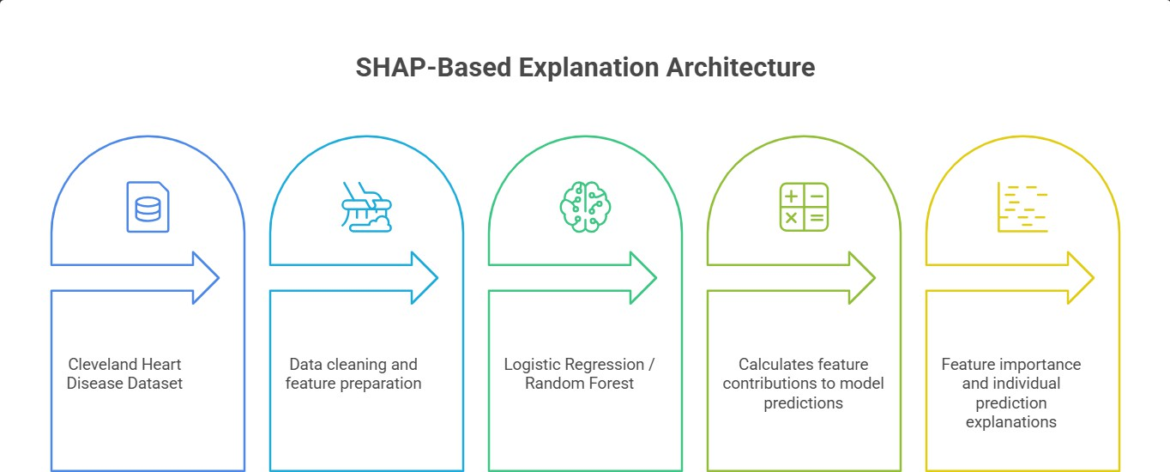

Fig.1. SHAP-Based Explanation System

LIME-Based Explanation System
LIME (Local Interpretable Model-Agnostic Explanations) explains individual predictions by approximating a model locally with a simpler, interpretable model. It helps identify features that influence a specific prediction. However, its explanations may vary depending on sampling and perturbation settings, making consistent evaluation important.

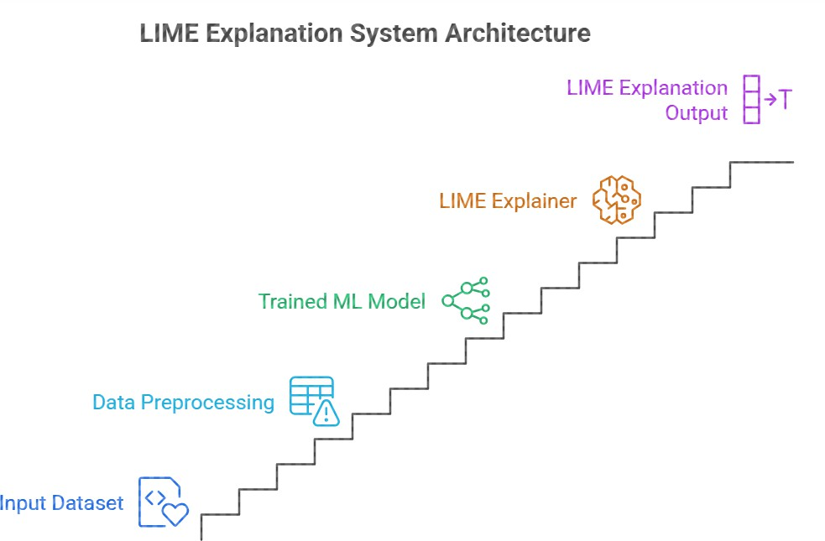

Fig.2. LIME-Based Explanation System

Existing XAI Evaluation Methods
Existing XAI evaluation methods use different metrics to examine explanation quality. Faithfulness measures how well explanations reflect model behaviour, stability examines consistency under controlled input changes, and sparsity considers the number of features used in an explanation. However, inconsistent evaluation procedures can make comparisons between explanation techniques difficult.

Proposed System
The proposed system aims to compare SHAP and LIME using the Cleveland Heart Disease Dataset, with Logistic Regression and Random Forest as baseline models. It evaluates explanations using faithfulness, stability, and sparsity under documented experimental conditions. The goal is to provide a more consistent and reproducible framework for comparing XAI techniques

Research Gaps
Existing Explainable Artificial Intelligence (XAI) techniques such as SHAP and LIME help explain the predictions made by machine learning models. However, comparing these techniques is challenging because their explanations may differ in accuracy, consistency, and complexity. There is a need for a standardized framework to evaluate and compare these explanation methods under the same experimental conditions.

The major research gaps identified for this project are:

- Lack of Standardized Evaluation: There is a need for a common framework to compare SHAP and LIME using consistent evaluation criteria.

- Limited Comparison of Explanation Methods: The performance of SHAP and LIME needs to be compared across machine learning models such as Logistic Regression and Random Forest.

- Faithfulness Evaluation: It is important to evaluate whether the explanations accurately represent the features influencing the model's predictions.

- Stability of Explanations: Explanations should be consistent when small changes are made to the input data or experimental conditions.

- Sparsity of Explanations: There is a need to evaluate whether explanations can identify the most important features without including unnecessary information.

- Reproducibility: A standardized and reproducible evaluation process is required so that the results of different XAI methods can be compared fairly.

Chapter 3: Proposed System

Problem Statement and Objectives
    - Problem Statement
The system aims to address the lack of a standardized and repeatable approach for evaluating and comparing Explainable Artificial Intelligence (XAI) techniques. Different explanation methods may produce different results, making it difficult to assess their reliability and usefulness under consistent experimental conditions.

Objectives
      - To develop a repeatable workflow for loading and preprocessing a tabular dataset.
      - To train and evaluate Logistic Regression and Random Forest classifiers.
      - To generate model explanations using SHAP and LIME.
      - To evaluate explanations using faithfulness, stability, and sparsity metrics.
      - To compare SHAP and LIME under consistent experimental conditions.
      - To present evaluation results through suitable charts and graphs.

Scope

The documented baseline scope is the Cleveland Heart Disease Dataset, Logistic Regression and Random Forest, and SHAP and LIME explainers. Any additional datasets, models, explainers, or interface functions should be included only if they are part of the final verified implementation.

System Architecture
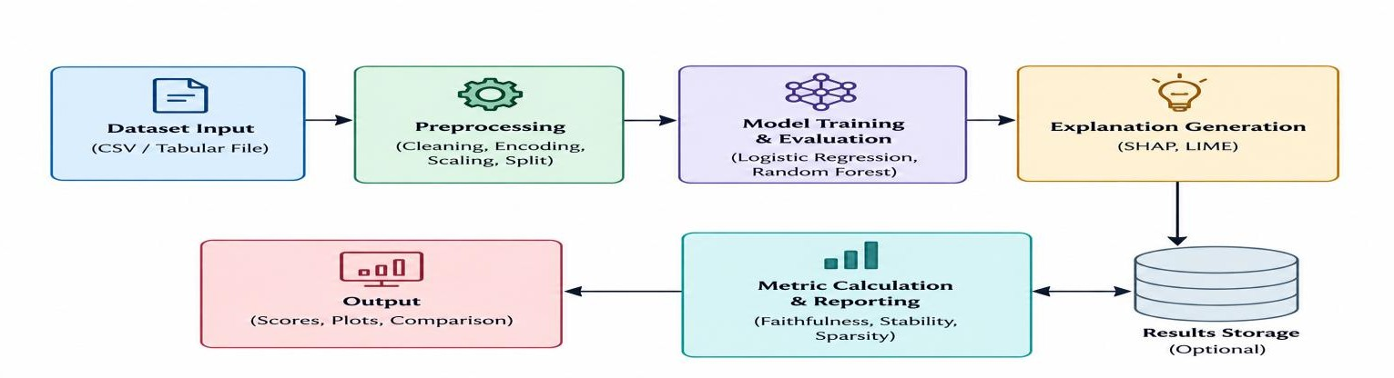
Fig.3. System Architecture

Methodology

- Obtain the Cleveland Heart Disease Dataset and record the exact source, filename, and version.
- Inspect the schema, target column, feature types, missing values, and class distribution.
- Preprocess the data using a documented strategy; fit transformations using training data only where applicable.
- Train Logistic Regression and Random Forest using a fixed, recorded split and random seed.
- Generate SHAP and LIME explanations for selected held-out test instances.
- Calculate faithfulness, stability, and sparsity using stated formulas, thresholds, perturbation settings, and metric directions.
- Aggregate results into tables and plots; repeat runs where needed and discuss uncertainty and limitations.

System Design

The benchmark should retain the model name, explainer name, instance identifier, metric formula/version, configuration, value, direction, and interpretation for every reported score. This information helps distinguish differences caused by explanation methods from differences caused by data or configuration.

Evaluation Dimensions
Table.2:-
Metric | Purpose | Reporting requirement
Faithfulness | Examines whether an explanation reflects the model's behaviour. | Specify perturbation/removal procedure, formula, scale, and whether lower or higher is better.
Stability | Examines consistency of explanations under controlled changes to an input. | Specify perturbation magnitude, distance/similarity measure, and aggregation.
Sparsity | Examines how compact an explanation is in terms of features used. | Specify attribution threshold or attribution-mass rule and whether the reported value is a count or fraction.

Hardware and Software Requirements

Table.3:-
Category | Requirement
Hardware | Laptop or desktop; 8 GB RAM recommended for the small tabular-data workflow.
Operating system | Windows, Linux, or macOS.
Language | Python 3.10 or a compatible version used by the final environment.
Libraries | pandas, NumPy, scikit-learn, SHAP, LIME, plotting library, and any libraries required by the final implementation.
Storage | Local project folder for source code, dataset, configuration, outputs, and plots.
Interface | A local research interface or notebook, depending on the verified implementation.

Implementation plan

Table.4:-
Module | Function | Expected output
Dataset loader | Read the dataset and validate required columns. | Data summary and validation messages.
Preprocessing | Handle missing values and prepare model inputs. | Reproducible training/test data.
Model module | Train selected classifiers and obtain held-out predictions. | Model objects and predictive metrics.
Explainer module | Generate SHAP and LIME explanations. | Feature-attribution outputs.
Metric module | Calculate faithfulness, stability, and sparsity. | Metric values with documented definitions.
Reporting module | Display/export scorecards and plots. | Comparison tables and figures.

Testing and Evaluation
Table 4: Illustrative test cases

Test ID | Test scenario | Expected result | Status
TC01 | Load valid dataset | Data loads and expected columns are detected. | To verify
TC02 | Dataset has missing values | Missingness is reported and documented policy is applied. | To verify
TC03 | Target column is absent or invalid | Clear validation error is raised. | To verify
TC04 | Train Logistic Regression | Model fits and returns held-out predictions. | To verify
TC05 | Train Random Forest | Model fits with recorded random seed. | To verify
TC06 | Generate SHAP output | Attributions are produced for the supported model/input. | To verify
TC07 | Generate LIME output | Local explanation is produced for a selected test row. | To verify
TC08 | Calculate faithfulness | Finite output and metric direction are documented. | To verify
TC09 | Calculate stability | Perturbation and similarity procedure is reproducible. | To verify
TC10 | Calculate sparsity | Feature count/fraction follows the stated threshold. | To verify
TC11 | Repeat using same seed | Deterministic parts reproduce the same outputs. | To verify
TC12 | Export scorecard | Exported output contains values and configuration. | To verify

Chapter 4: Results and Conclusion

RESULTS:-
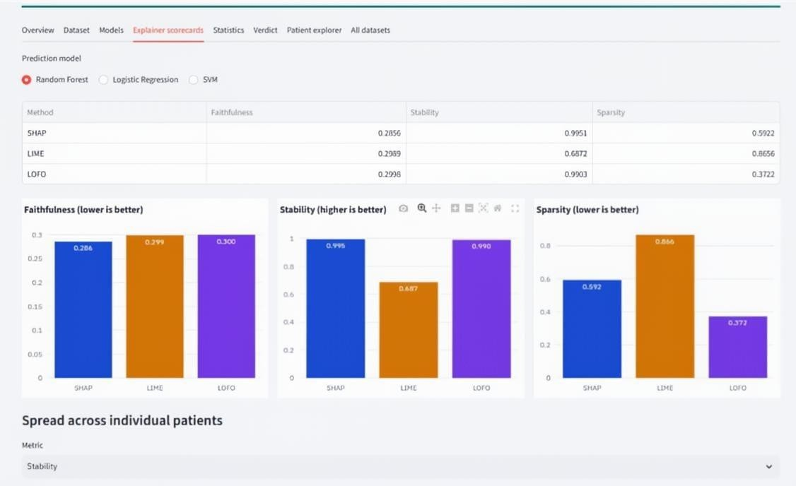

FIG. 4. RANDOM FOREST EVALUATION
The first image shows how SHAP, LIME, and LOFO explain an individual patient's prediction. The dashboard reports a predicted Death Event probability of 19.1%, with the model prediction and recorded outcome both shown as “Survived.” The bar charts display the contribution of different features according to each explanation method. The cosine similarity table compares how closely the methods agree, with SHAP–LIME at approximately 0.88, SHAP–LOFO at 0.86, and LIME–LOFO at 0.825. These results indicate that the methods have a degree of agreement, although their feature explanations differ.

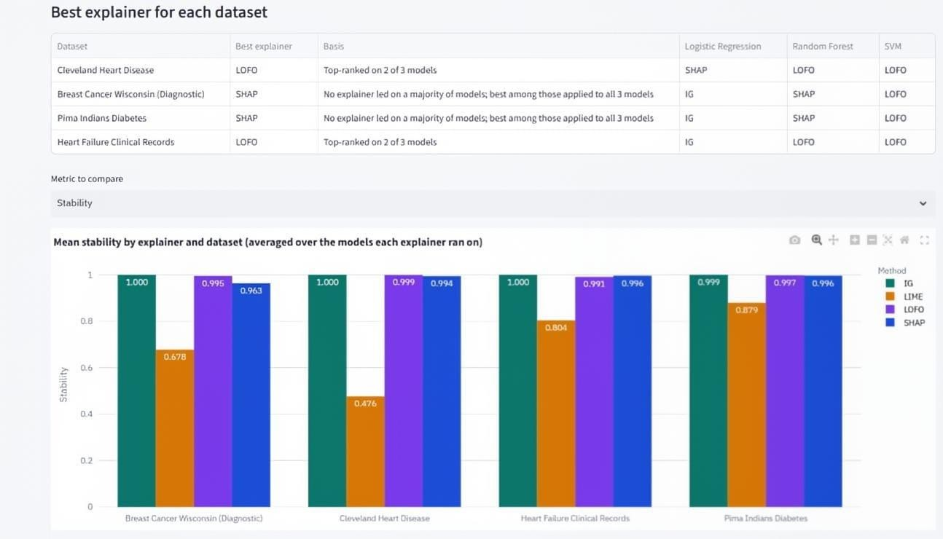
FIG. 5. MEAN STABILITY
The second image compares SHAP, LIME, and LOFO using faithfulness, stability, and sparsity. SHAP records a faithfulness score of 0.2856, stability of 0.9951, and sparsity of 0.5922. LIME records 0.2959, 0.6872, and 0.8656, respectively, while LOFO records 0.2998, 0.9903, and 0.3772. According to the dashboard's stated metric directions, SHAP performs best in faithfulness and stability, whereas LOFO has the lowest sparsity score. LIME shows lower stability than the other two methods in this particular comparison. The results demonstrate that performance varies depending on the evaluation metric.

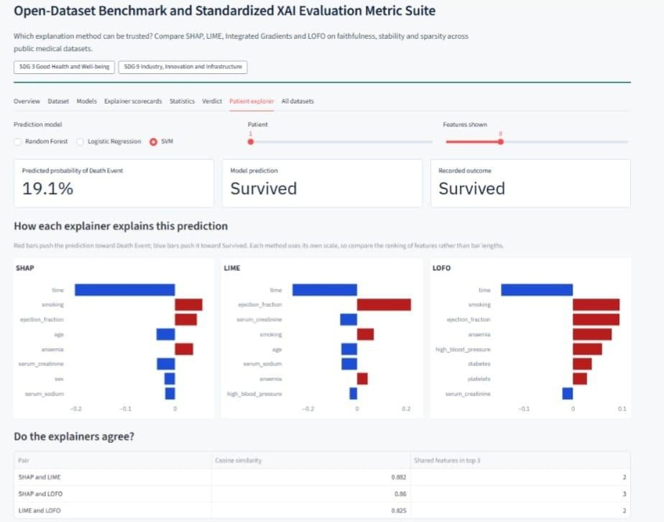
FIG. 6. SVM EVALUATION
The third image compares explanation methods across four datasets: Cleveland Heart Disease, Breast Cancer Wisconsin, Heart Failure Clinical Records, and Pima Indians Diabetes. The table identifies LOFO as the best explainer for Cleveland Heart Disease and Heart Failure Clinical Records, while SHAP is identified as the best for Breast Cancer Wisconsin and Pima Indians Diabetes. The bar graph compares mean stability across the datasets. Integrated Gradients and LOFO show stability values close to 1.0, while LIME has lower and more variable values. These results suggest that the most suitable explanation method can differ across datasets and machine learning models.

Result Interpretation
The comparison should not declare one explainer universally superior from a single score. The interpretation must consider metric definitions, model behaviour, feature dependencies, dataset size, perturbation assumptions, and whether the chosen metric captures the intended quality dimension. Comparisons should use the same instances and compatible settings wherever technically possible.

Conclusion

The project sets out a structured approach to comparing SHAP and LIME explanations through faithfulness, stability, and sparsity. Its main emphasis is on making experimental settings and metric definitions explicit so that explanation outputs can be compared more consistently. The final conclusion must be updated after the implementation has been executed and its outputs verified; no numerical conclusion is asserted in this draft.

Future Scope
    - Extend the benchmark to additional open datasets after validating the baseline workflow.
    - Evaluate further models and explanation techniques using the same documented protocol.
    - Add repeat-run uncertainty summaries and statistical comparisons where appropriate.
    - Improve export options and preserve configuration metadata with each scorecard.
    - Add robustness checks and document the limitations of perturbation-based evaluation.

References:-

[1] G. Makridis, V. Koukos, G. Fatouros, and D. Kyriazis, “VirtualXAI: A User-Centric Framework for Explainability Assessment Leveraging GPT-Generated Personas,” arXiv preprint arXiv:2503.04261, 2025. Available: https://arxiv.org/abs/2503.04261

[2] M. A. Qureshi, A. A. Noor, A. Manzoor, M. D. M. Qureshi, A. Younus, and W. Rashwan, “Explainability in Action: A Metric-Driven Assessment of Five XAI Methods for Healthcare Tabular Models,” medRxiv preprint, 2025. doi: 10.1101/2025.05.20.25327976. Available: https://doi.org/10.1101/2025.05.20.25327976

[3] T. Rai, J. He, J. Kaur, Y. Shen, M. Mahmud, D. J. Brown, E. O’Dowd, and D. Baldwin, “Evaluating XAI Techniques Under Class Imbalance Using CPRD Data,” Frontiers in Artificial Intelligence, vol. 8, article 1682919, 2025. doi: 10.3389/frai.2025.1682919.

[4] S. Hur, Y. Lee, J. Park, Y. J. Jeon, J. H. Cho, D. Cho, D. Lim, W. Hwang, W. C. Cha, and J. Yoo, “Comparison of SHAP and Clinician Friendly Explanations Reveals Effects on Clinical Decision Behaviour,” npj Digital Medicine, vol. 8, article 578, 2025. doi: 10.1038/s41746-025-01958-8.

[5] Y. Singh, Q. A. Hathaway, V. Keishing, S. Salehi, Y. Wei, N. Horvat, D. V. Vera-Garcia, A. Choudhary, A. Mula Kh, E. Quaia, and J. B. Andersen, “Beyond Post hoc Explanations: A Comprehensive Framework for Accountable AI in Medical Imaging Through Transparency, Interpretability, and Explainability,” Bioengineering, vol. 12, no. 8, article 879, 2025. doi: 10.3390/bioengineering12080879.

[6] N. A. Aziz, A. Manzoor, M. D. M. Qureshi, M. A. Qureshi, and W. Rashwan, “Unveiling Explainable AI in Healthcare: Current Trends, Challenges, and Future Directions,” medRxiv preprint, 2024. doi: 10.1101/2024.08.10.24311735. Available: https://doi.org/10.1101/2024.08.10.24311735

[7] “From Movements to Metrics: Evaluating XAI in Skeleton-Based Human Activity Recognition,” arXiv preprint arXiv:2402.12790, 2024. Available: https://arxiv.org/abs/2402.12790

[8] S. Ahmed, M. S. Kaiser, M. S. Hossain, and K. Andersson, “A Comparative Analysis of LIME and SHAP Interpreters With Explainable ML-Based Diabetes Predictions,” IEEE Access, vol. 13, pp. 37370–37388. doi: 10.1109/ACCESS.2024.3422319

[9] C. Agarwal, S. Krishna, E. Saxena, M. Pawelczyk, N. Johnson, I. Puri, M. Zitnik, and H. Lakkaraju, “OpenXAI: Towards a Transparent Evaluation of Model Explanations,” in Advances in Neural Information Processing Systems (NeurIPS), vol. 35, 2022.

[10] X. Li, M. Du, J. Chen, Y. Chai, H. Lakkaraju, and H. Xiong, “M4: A Unified XAI Benchmark for Faithfulness Evaluation of Feature Attribution Methods Across Metrics, Modalities and Models,” in Advances in Neural Information Processing Systems (NeurIPS), 2023. Available: https://openreview.net/forum?id=6zcfrSz98y

